Project 67 – Brief

Goal: Build a premium “0 → 6/7 figure” Business Kit platform, hybrid Apple + Design.com inspired, with one-time unlock, interactive dashboard, Specialist AI-powered generation, and upsell via additional dashboards.

Simple, premium, dark - Apple.

Name: Project 67

Simple- like Apple, or base 44 or anything big really

Why 67?

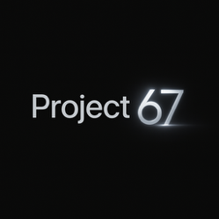We will iterate and emphasise this will give you everything you need to go from 0…. To 6/7 figures.

6/7figs will be everywhere when needed to reassure

BUT

also perfectly ties in with the viral ongoing trend that somehow still isn’t dying out and comes back every few months.

So we use it too build. (Not base us off of it.)

It makes our name memorable, people may talk abt it because of the coincidence.

Seeing 6/7 everywhere makes people think it was done purposely but because of how premium we are they can’t come to believe it.

Give ours project lore

⸻

1. Vision & Positioning

• Name: Project 67

• Tagline / Hook: Everything you need to go from 0 → 6/7 figures.

Built with the knowledge of founders, creators, and specialists who dominate.

The worlds next rise of millionaires begins here.

Welcome to Project 67.

Subsection: “Your Idea x Social media (used correctly)= Lottery… (Biased to Win)”

• Goal: Give users everything they need to go from 0 → 6/7 figures, in a premium, intentional, simple, yet audacious platform.

• Vibe: Clean, minimal, cinematic Apple-style UI; interactive, inspirational, aspirational; emphasizes focus and depth over constant switching.

• Payment Philosophy: One-time unlock (£37) + optional hosting (£3/month)- to keep website live- can pause hosting and website is frozen but still there like in the shadows for when they want to come back.

State clearly: No subscriptions, no hidden fees, no micro-packages.

•note: Upsell: Additional dashboards via credits for exploring new business ideas. Ensures they don’t idea hop and rinse our service.

⸻

2. Landing Page / Hook Section

Objective: Immediately communicate value, grab attention, encourage progressive entry or tab-skipping flow.

Microcopy & Motion:

• Everything you need to go from 0 → 6/7 figures.

Built with the knowledge of founders, creators, and specialists who dominate.

The worlds next rise of millionaires begins here.

Welcome to Project 67.

• Optional: Dynamic motion background or subtle cinematic animation (Apple-style) for premium feel.

Progressive Entry Flow:

• Single input for business idea and challenges. Optional hints: (add or don’t add whatever you think is helpful)

• Business name

• Niche / Industry

• Target audience

• Primary goals

• Biggest current struggle (optional, helps AI tailor outputs)

• impatient Users can skip progressive entry via top tabs – just like design.com how u can jump.(Business Case, Content Strategy, Website).

⸻

3. Tab / Navigation System

Tabs: Business Case / Identity | Content Strategy | Website

Logic:

• Users must complete all 3 tabs to access checkout.

* + KEY: As soon as they click generate on any tab they are directed first thing to sign up (like base 44- as soon as u click generate it gives a sign up pop up every single time u click so u js need to sign in to test it) and then continue (that’s when they get there free generations. So after that payment is seamless as they are already signed up.

• After marking a tab “Complete”:

• If others incomplete and they try to checkout → redirect to first incomplete tab with soft notification: “You have 2/3 sections complete. Please finish the remaining sections before checkout.”

• Tabs allow impatient users to generate specific sections immediately.

Feel free to keep ai question and hints the same so it still applies to all 3 and they only have to answer once regardless of wether they start from start or skip a tab.

⸻

4. Content Generation Logic

4.1 Business Case / Identity

• AI generates 1 complete set of business blueprint + 3 actionable next steps.

• Regeneration Limits: 1 regeneration for the first output (rare fluke or alternate angle).

• Microcopy:

• “This AI is trained by industry experts in business strategy to give you your ideal business blueprint instantly. One generation is usually perfect.”

• Next Steps Generation Buttons:

1. Incomplete Next Steps: Alternative approach if user couldn’t start with initial steps.

KEY!!! (So the next steps generate button is available disconnected too the business case. They could be happy with the case but can’t start there and want somewhere else too start. This should be available both here and in dashboard.

2. Completed Next Steps (after checkout on dashboard)

An additional generate button for NEXT STEPS after completing previous.

If hasn’t completed previous and wants diff steps instead then can regenerate diff and then continue.

Generates next-level steps after completing the first set.

• unlimited regeneration for additional options is allowed after checkout ofc.

4.2 Content Strategy

• AI generates 3 actionable content ideas.

• Regeneration Limits: 1 pre-checkout; unlimited post-checkout.

4.3 Website Generation

• 8 initial interactive templates (Design.com style).

• Unlimited regeneration until final design selection.

• Apple-style minimal UI, idk how customisable you want the templates to be that’s up to you boss- not crazy deep.

⸻

5. Dashboard Design & UX

Style: Hybrid Apple minimalism + Design.com interactivity.

• Clean typography, cinematic transitions, smooth hover/motion effects.

• Cards/Panels:

1. Business Case / Identity

2. Content Strategy

3. Website

4. Optional Info Panel (hints, tips, microcopy)

UX Notes:

• Clickable & expandable cards.

• Visual feedback for completion: green checkmarks.

• Regeneration buttons clearly distinguish incomplete vs completed next steps.

• Progressive flow optional; tab navigation always gently redirects if trying to checkout incomplete.

• Micro-Apple-style welcome message: “Welcome, your success awaits you”.

⸻

6. Checkout & Hosting

Payment Model:

• £37 one-time unlock → full access to dashboard and all AI features.

• £3/month hosting fee (first 2 months free).

• Checkout blocked until all sections are marked complete.

Upsell / Credit System:

• Additional Dashboard Credits:

• 1000 = £12.99

• 500 = £6.99

• Credits only unlock new dashboards; purchased in bulk, deducted on creation.

• Dashboard Locking Principle: Each dashboard is locked to its chosen business idea to encourage focus.

• At- checkout microcopy:

• “You will not be able to change this idea. This ensures you focus and actually build success — not just keep generating new businesses. You can unlock additional dashboards anytime with credits.”

⸻

7. Psychological Copy / Positioning

• Premium value emphasized: “Apple-style simplicity, intentional, no hidden fees, no fluff.”

• Reassure users about AI quality: “Expert-backed, optimized for maximum success.”

• Scarcity & focus: One dashboard per business idea → encourages depth, not constant switching.

⸻

8. Additional Notes for Engineer / Designer

• Haider will provide example outputs (like design.com has on each bookmark/tab) and pre-prompts (to perfect the ai output as done with content Strat) for each steps and business case aswell.

• Regeneration logic microcopy must be clear.

• Dashboard cards summarize AI outputs & completion at a glance.

• Smooth animations and transitions between tabs and sections.

• Optional cinematic background for landing page.

• Credit purchase flow: confirm deduction → new dashboard creation.

⸻

9. Core Model Summary

1. User Flow:

1. Progressive entry OR tab selection → AI generation → “Complete” → checkout → dashboard unlock.

2. Only one regeneration per section pre-checkout (Business Case/Next Steps & Content Strategy) but unlimited website like design.com cuz website can’t always be perfect.

3. Unlimited post-checkout regeneration for content strategy & website and business case(although it will rarely change cuz I mean it’s a business case…. Will probably just change wording slightly each time like uve already done) - and ofc next steps unlimited

2. Dashboard Principles:

• Locked to a single business idea.

• Optional additional dashboards via credits.

• Interactive, Apple + Design.com inspired UI.

3. Payment:

• One-time £37 unlock + £3/month hosting.

• Additional dashboards via credits (£6.99–£12.99).

£6.99 = 500 credits

£12.99 = 1000credits

New dashboard =750credits

So only evens out if they want 2 new dashboards = 1500 credits. Helps out those who want extra and helps us out by encouraging more dashboards (250 leftover credits might aswell buy 500 more and unlock a new dashboard)

4. Why it works:

• Premium, intentional, aspirational UX.

• Encourages focus and execution.

• Upsell via additional dashboards without cluttering UI.

• Clean, Apple-style aesthetic with interactive dashboard keeps users engaged.

⸻

✅ Deliverable for Engineer:

• Fully interactive dashboard with AI integration (Business Case, Content Strategy, Website).

• Regeneration logic as specified.

• Tab navigation, progressive entry, completion tracking, microcopy.

• Checkout + hosting + credit system.

• Apple + Design.com hybrid UI with smooth animations, interactive cards, and cinematic landing.

10. Visual Theme & Colour Direction

• Overall Aesthetic: Premium minimalism with cinematic polish — a mix between Apple’s calm precision and Design.com’s interactive clarity.

• Core Colours:

• Matte black / deep charcoal for backgrounds (luxury base).

• Soft whites and silvers for contrast and light zones (Apple-inspired minimalism).

• Accent colour: a subtle, glowing neon or metallic 67-stroke used sparingly (loading animation, logo mark, section transitions).

• Typography: Clean sans-serif, medium weight — think SF Pro Display or similar — with generous spacing and smooth motion transitions.

• Motion Language:

• Subtle fade-ins, parallax scroll, and light gradients that move slightly on hover.

• “67” subtly animates in on load, glowing briefly or tracing its outline — premium but mysterious.

• Psychology of Colour: The dark-to-light contrast makes users instantly feel they’re entering a high-end environment (trust, money, growth). The 67 accent gives it its own personality — not just premium, but viral-premium.

• Tone: Calm confidence. Every element feels intentional and “designed to win.”

References:

<https://www.design.com/business-cards> Layout

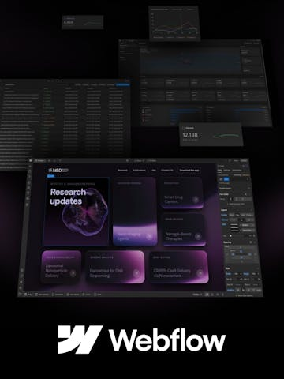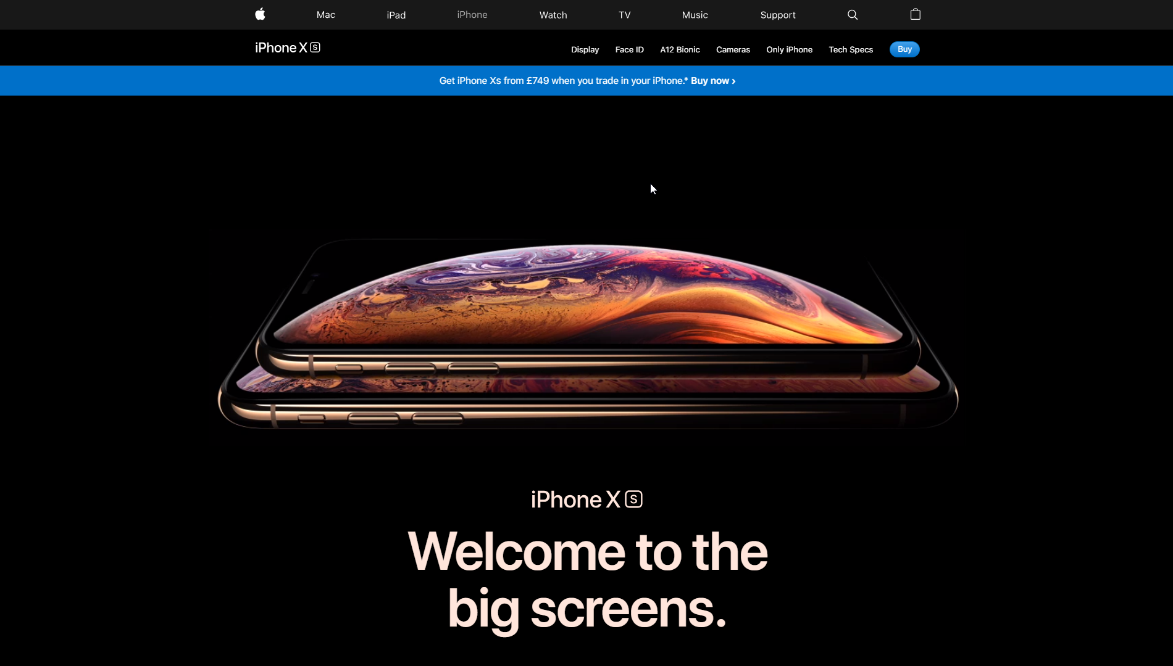Dark theme but ofc like above said silver metallic / white light (like old apple)- dashboard look alike on right? – u might know better inspiration